Machine Description | SickOS 1.1 simulates a small Linux web server hosting a custom monitoring script. The script executes system commands without proper sanitization, allowing attackers to achieve remote code execution and escalate to root through misconfigured local permissions.
Target IP | 10.136.108.108
Vulnerability Name | Command Injection in Web Monitoring Script (Unauthenticated RCE)
Service / Version | TCP / 80 HTTP via Squid Proxy
CVSS Score / Severity | 9.8 Critical
Attack Vector | AV:N/AC:L/PR:N/UI:N/S:U/C:H/I:H/A:H
Proof Of Concept | STEP 1 – Discover the Target IP using the Netdiscover  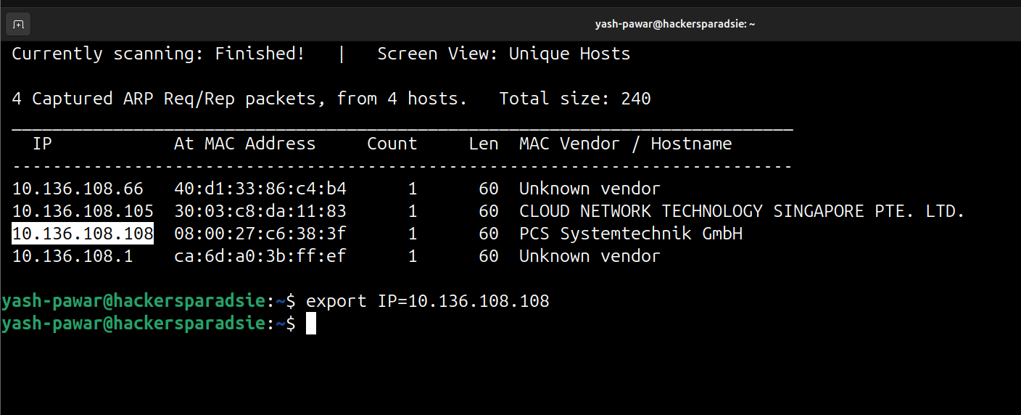  STEP 2 – Scan Open ports and Services on the target using Nmap  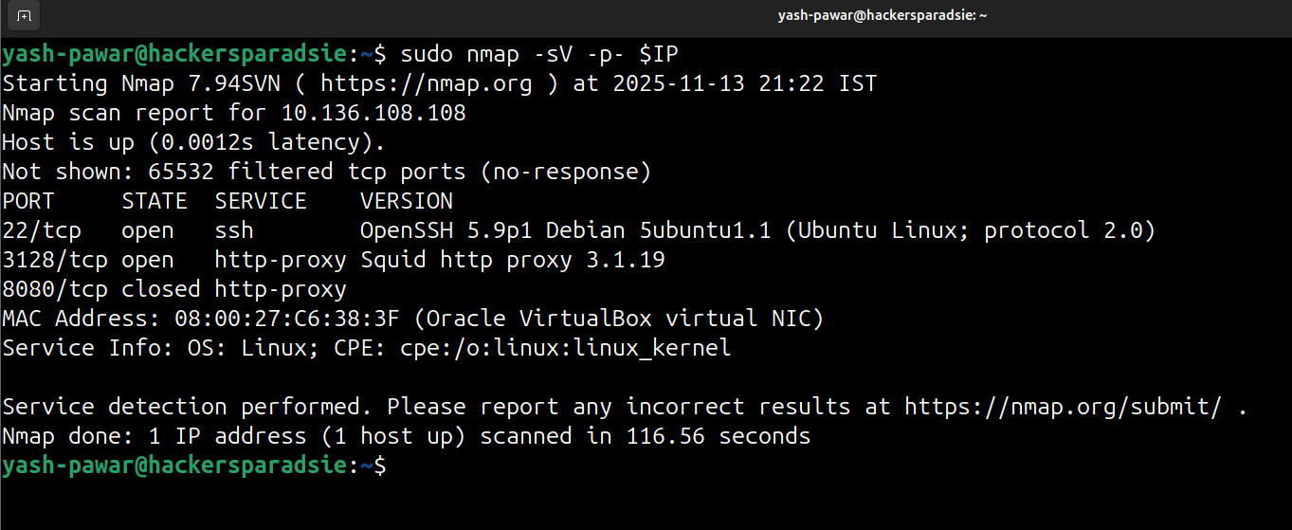  - we have the port 80 closed. So it’s clear that we can access the website via proxy port. Let’s check whether we open it in the browser or not.  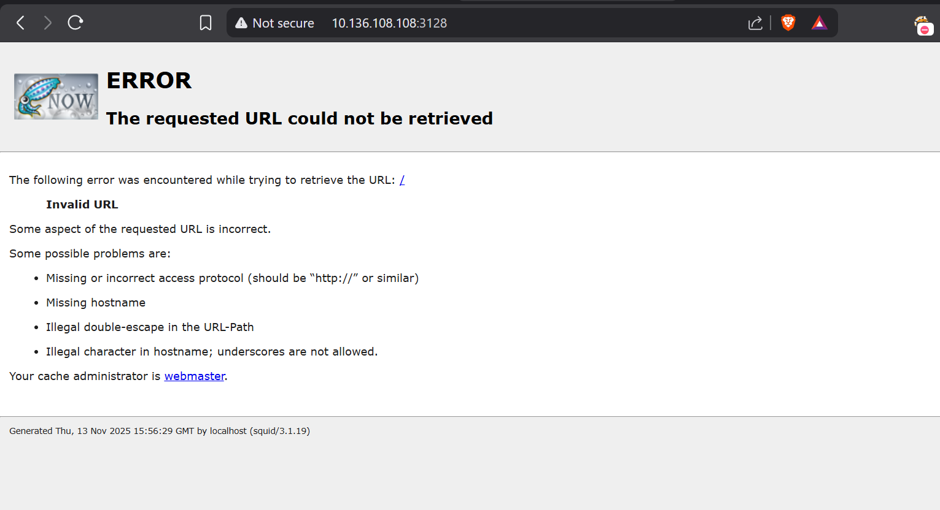  - Doesn’t seems to be working.  - Let’s try Browser manual to check for the directories and for the vulnerabilities via proxy.  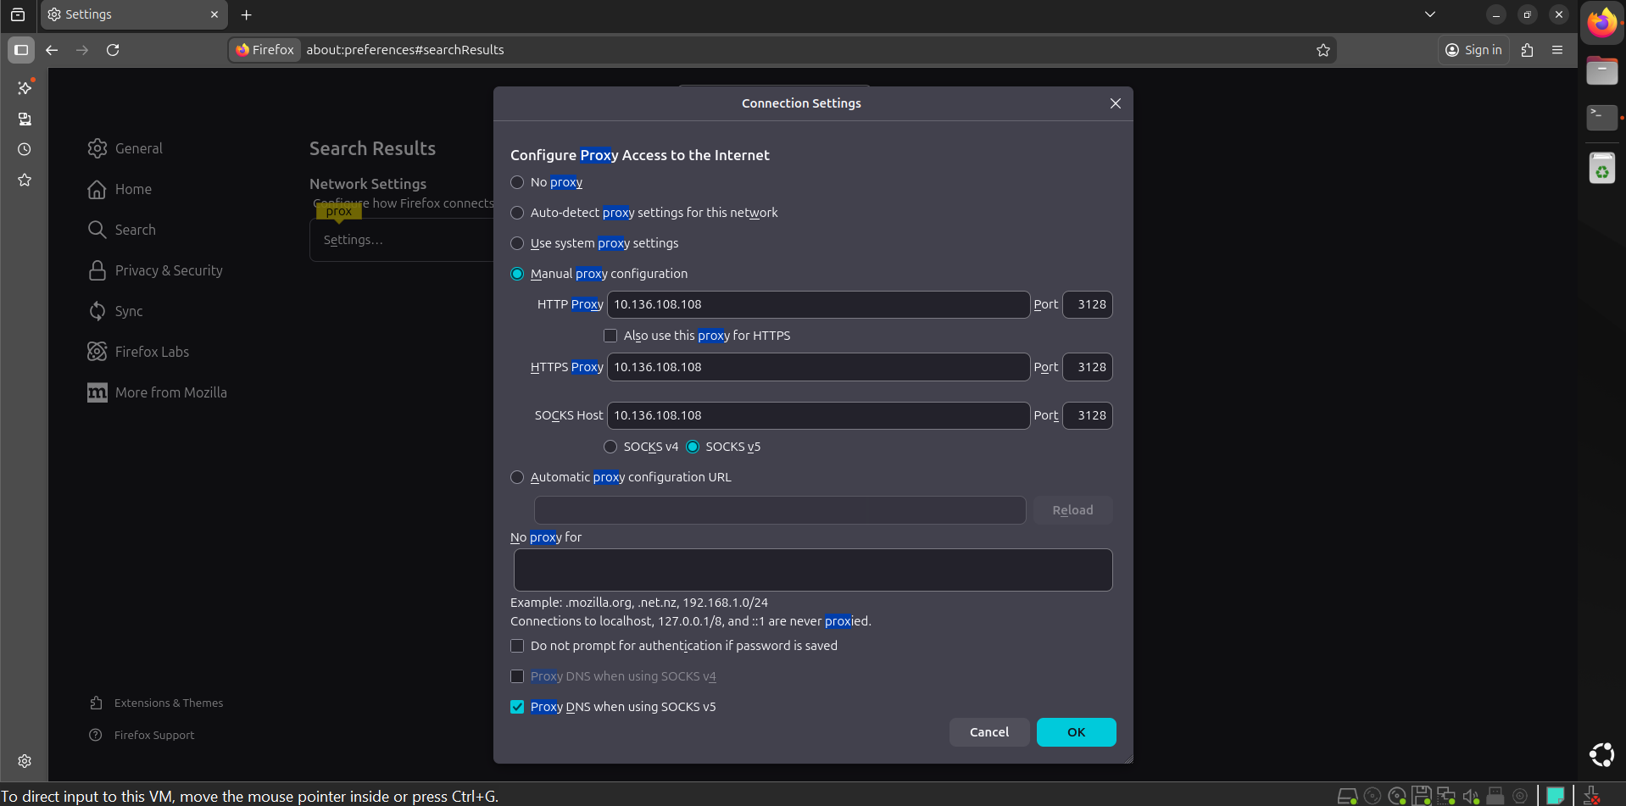  - So we got access to content through the proxy  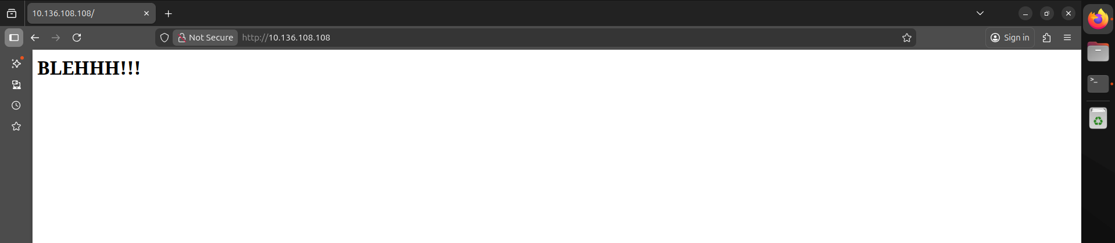  STEP 3 – Enumerating the webpage and hosted content  - We got info about kernel  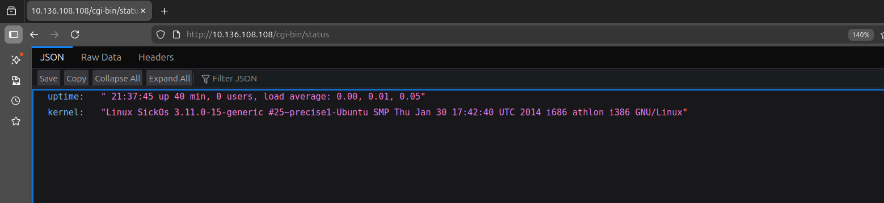  - /wolfcms directory on server from robots.txt  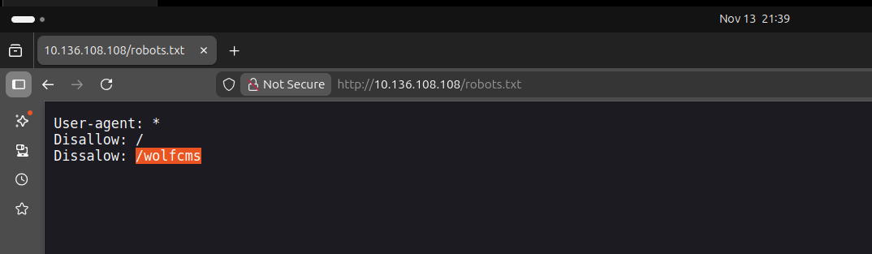  - Lets see what’s in directory  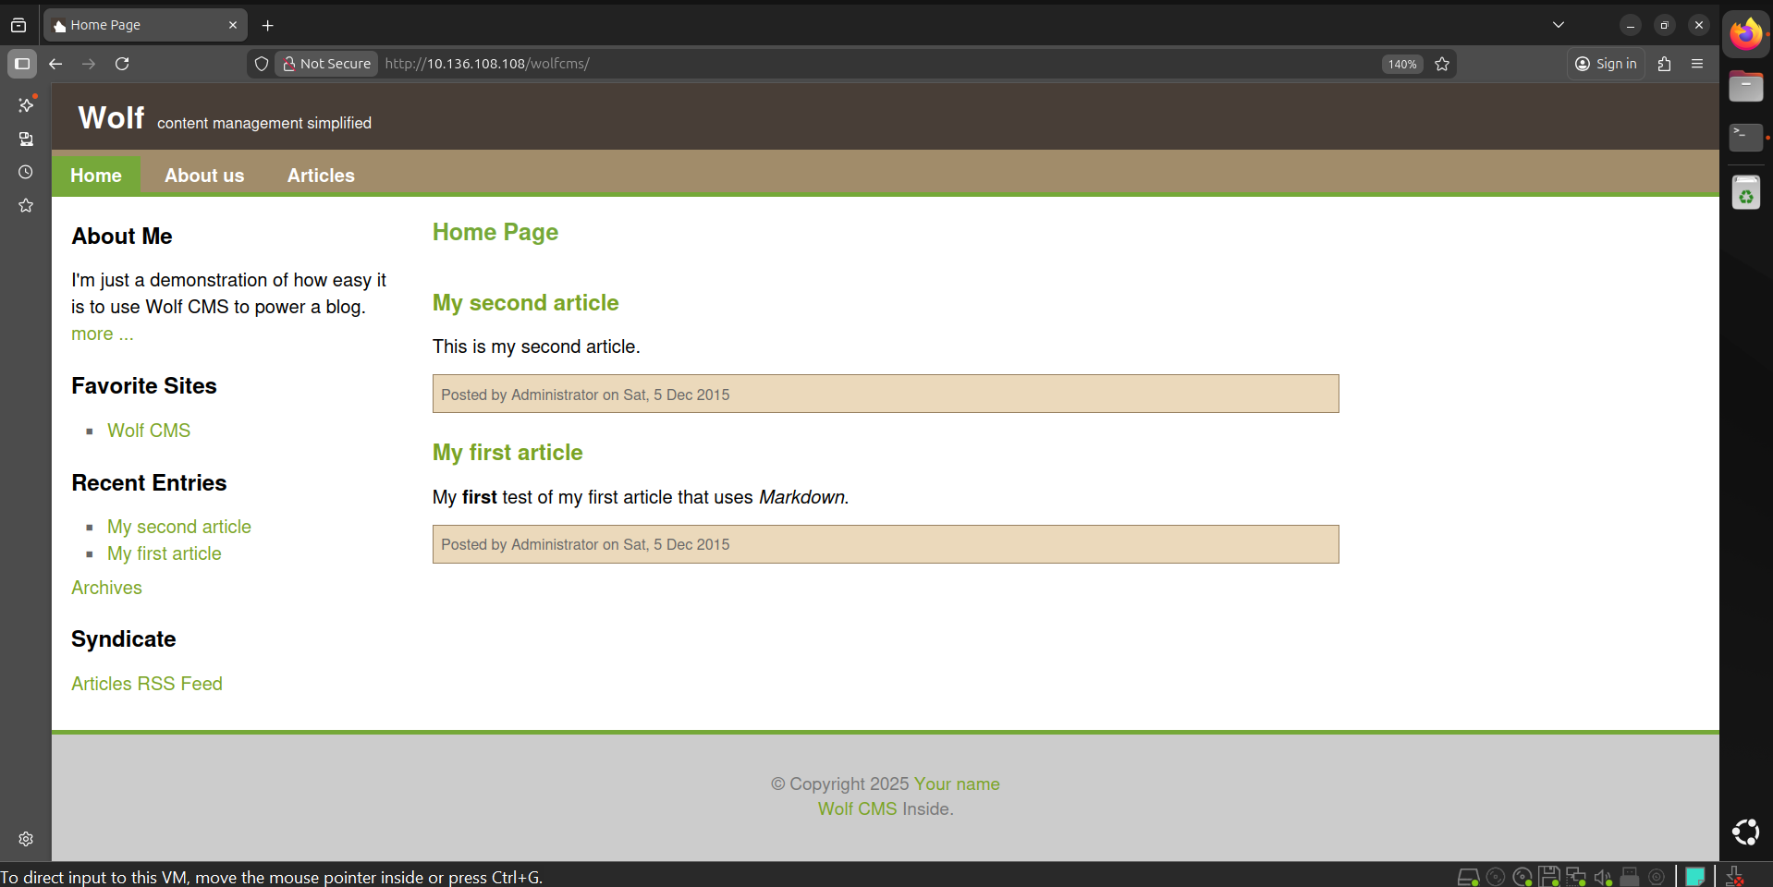  STEP 4 – Enumerating CMS  - We got admin panel at /?/admin/login  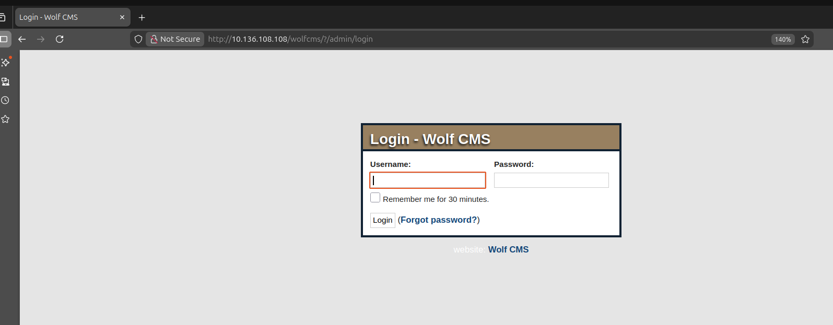  - Let’s try the default credentials of every admin panel (admin : admin )  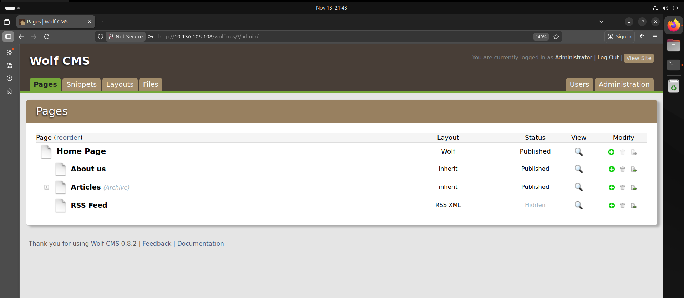  - We can see we have upload functionality on CMS which upload on /uploads directory  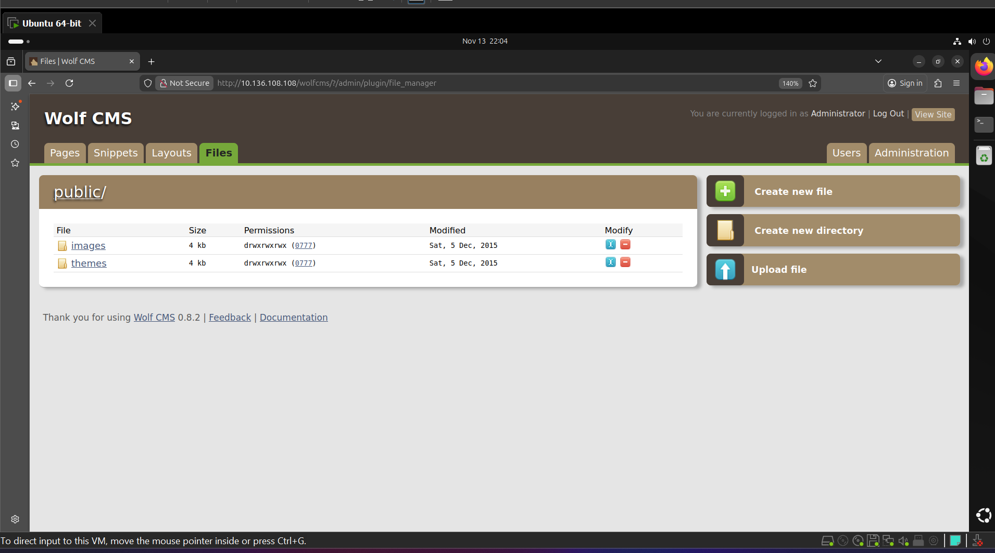  STEP 5 – Lets upload PHP Reverse shell uploading is not possible but lets create one  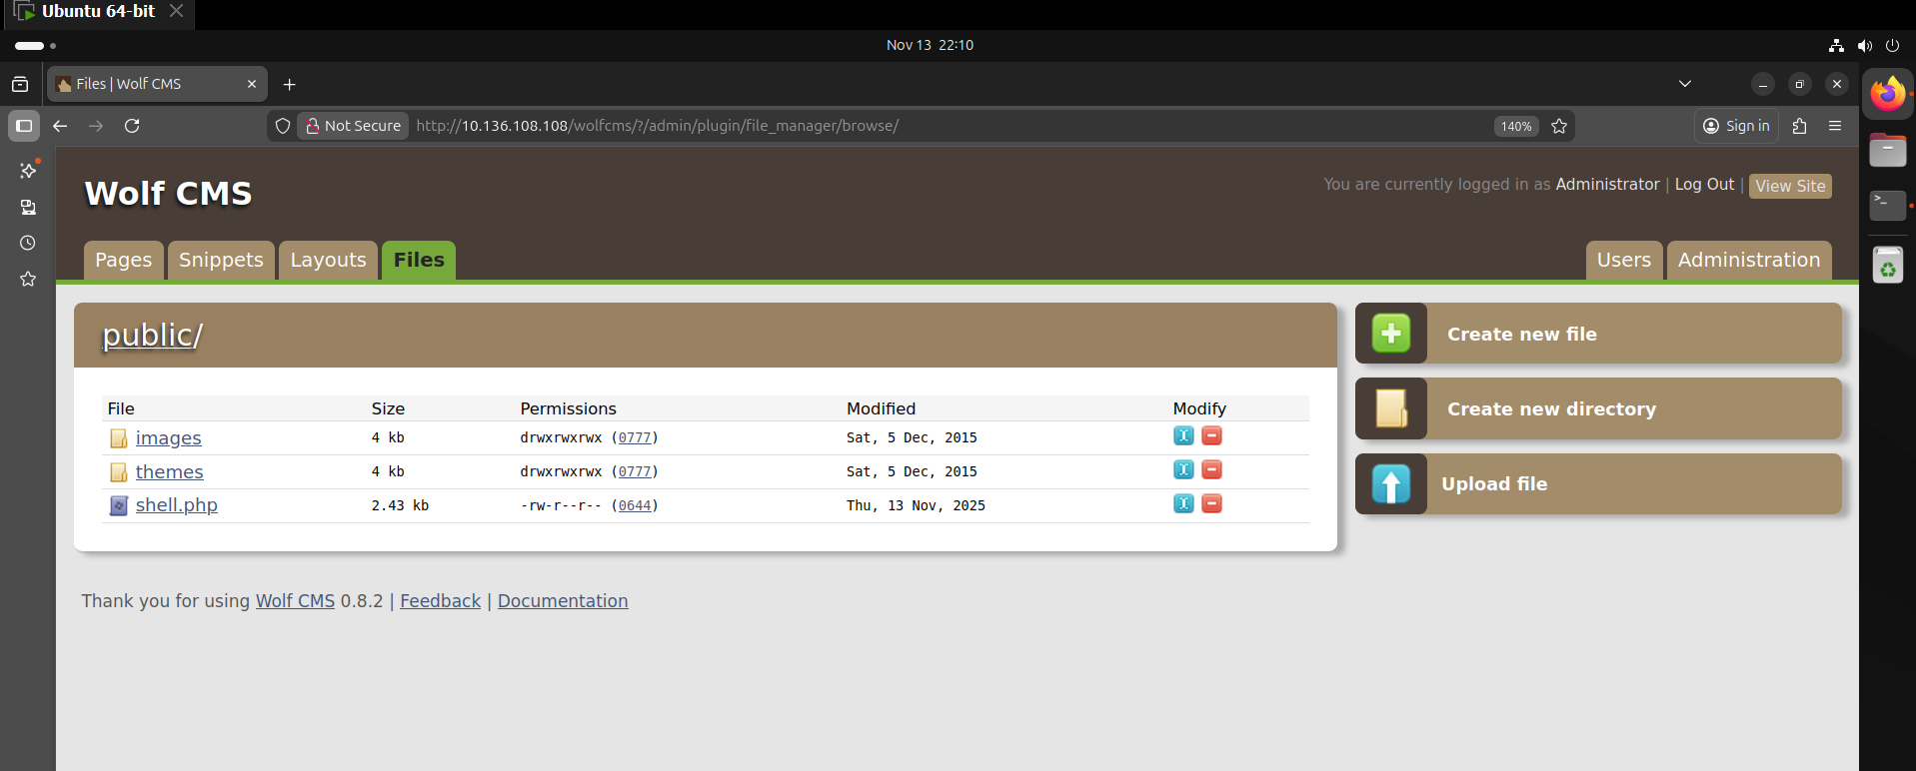  - Lets visit /public directory and try to access the shell  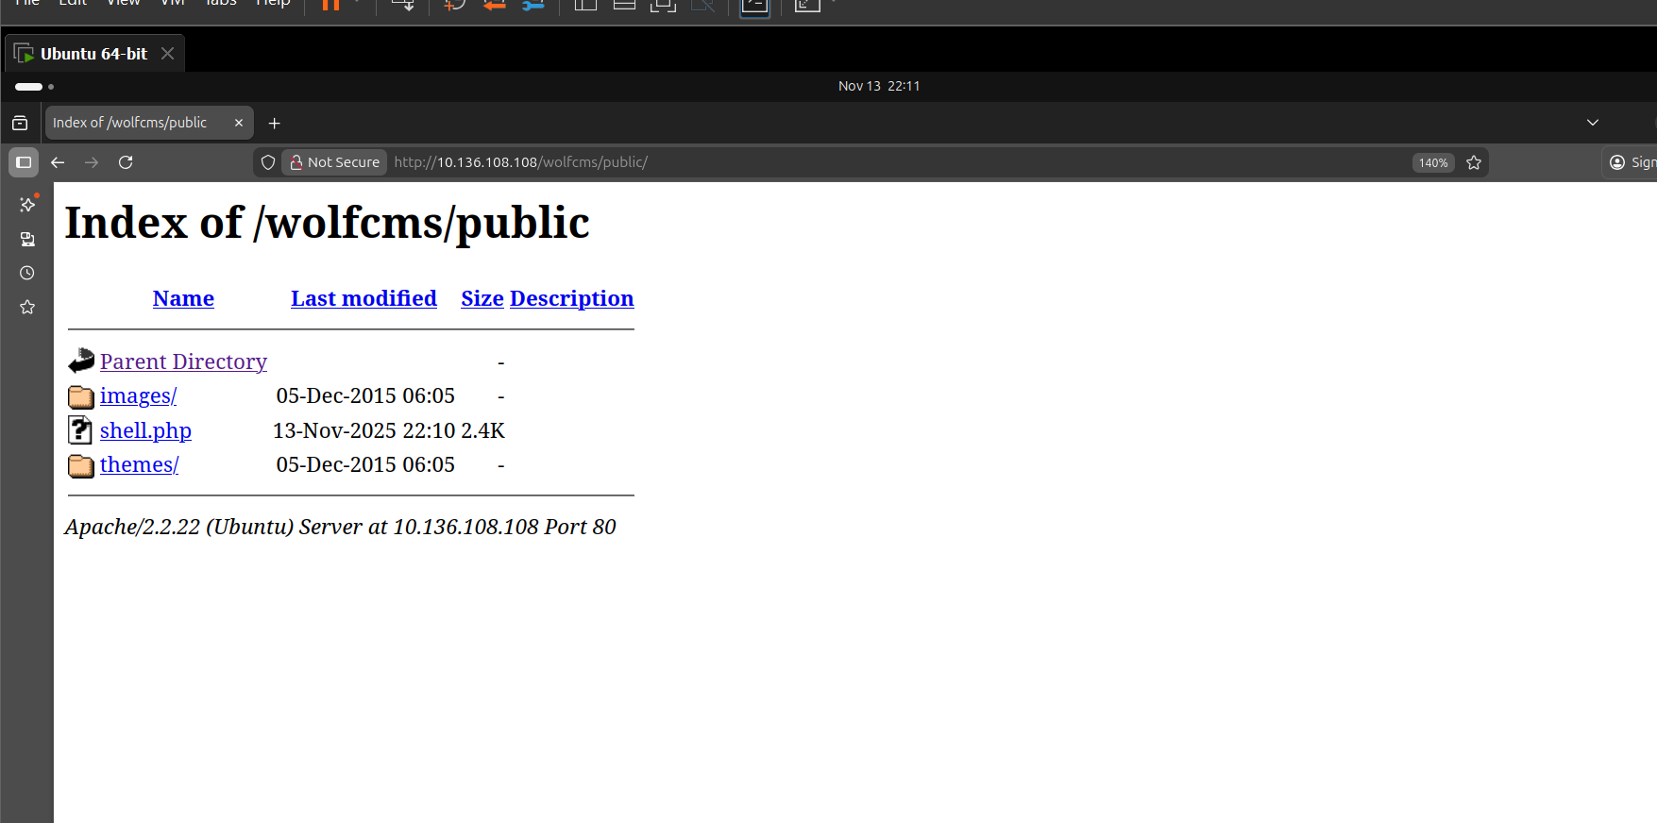  - When we click on shell.php we will get reverse shell on our netcat listner  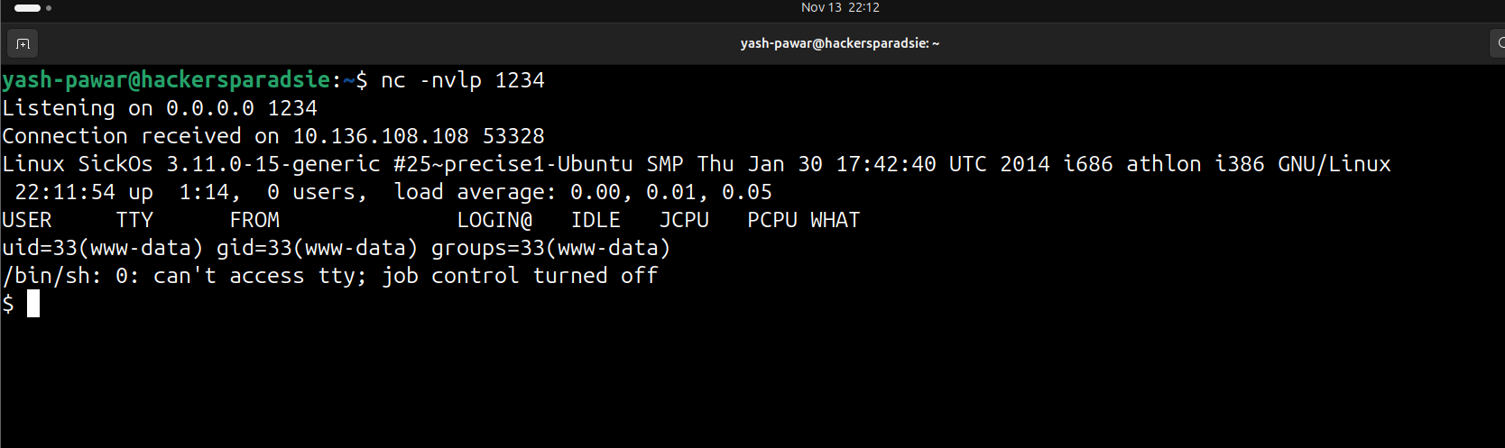  STEP 6 – Making Shell Stable  - Setting tty  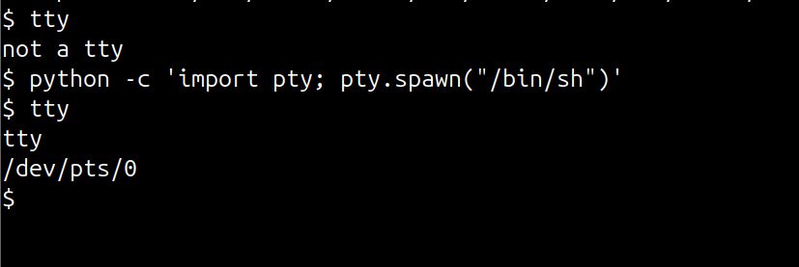  - Setting Environment  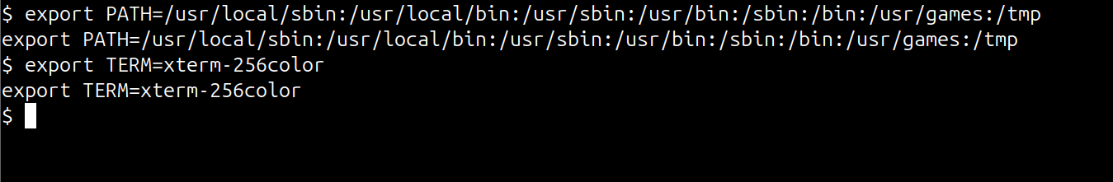  - Restarting shell for good stability  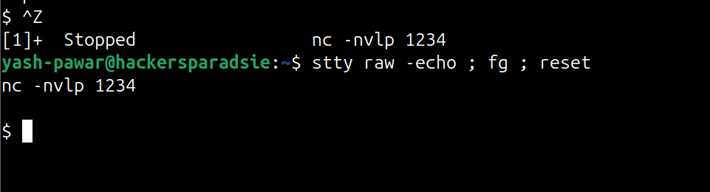  STEP 7 – Local Enumeration where we got the config.php in /var/www/wolfcms  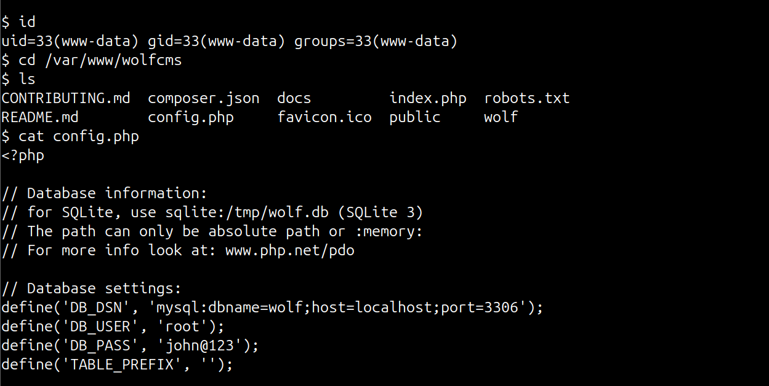  - Here we got creds for MYSQL( john@123 ) we can try it for SSH but we first need valid users on target so lets check /etc/passwd or home directory  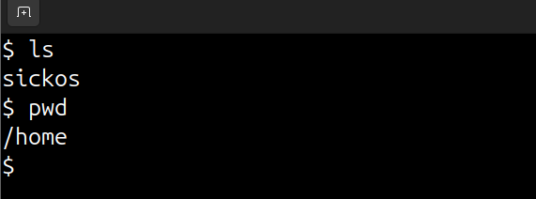  Only one user home directory here it means user is sickos  STEP 9 – Authenticate using SSH due to password reuse same as MYSQL login  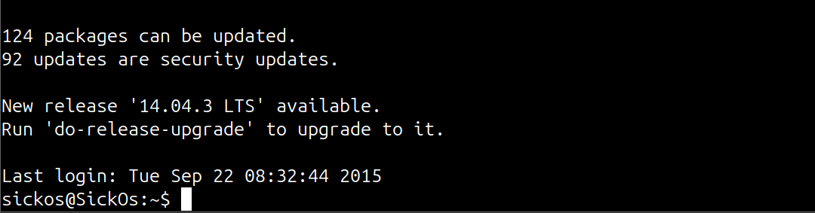  - Also sickos is member of sudo so lets swith to root  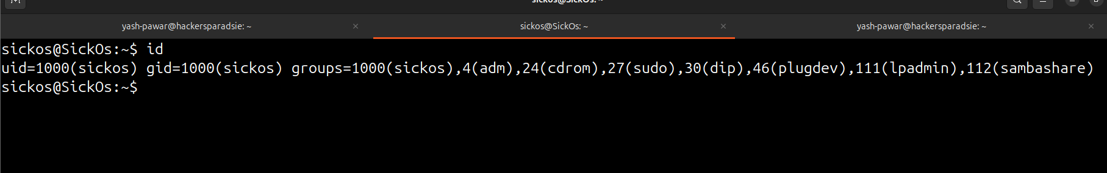  - Got ROOT  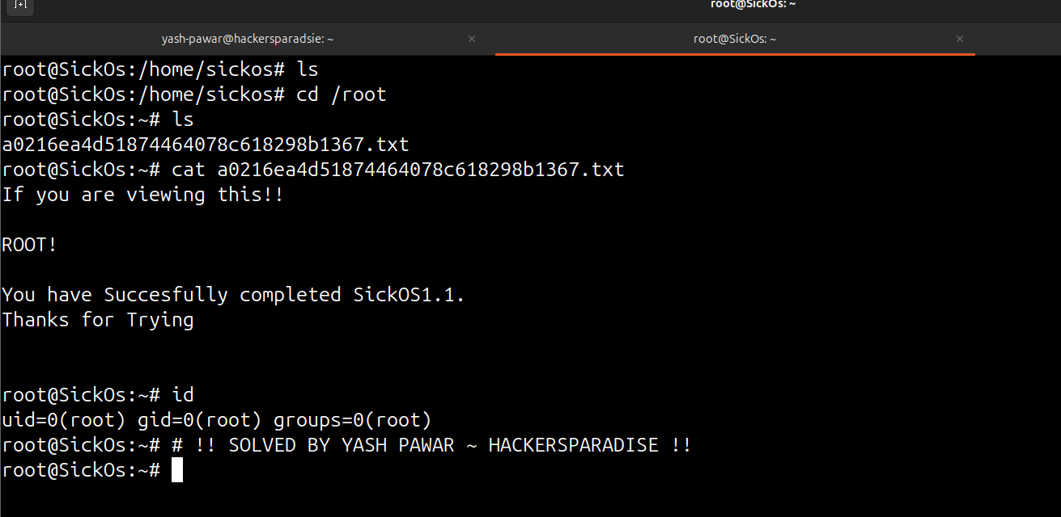
Impact | - Remote attacker can execute OS commands directly via web interface.  - Easy lateral movement because attacker gains full shell as www-data.  - With SUID escalation misconfig, attacker becomes root.  - Complete compromise of web application, database, and host filesystem.
Remediation | - Remove or sanitize the vulnerable script; enforce strict input validation.  - Disable command execution features in web forms unless absolutely required.  - Audit and remove unnecessary SUID binaries; enforce least-privilege.  - Keep Linux packages updated and restrict external access to administrative paths.
Reference | https://nvd.nist.gov/vuln/detail/CVE-2014-6271  https://cve.mitre.org/cgi-bin/cvename.cgi?name=CVE-2014-6271  https://nvd.nist.gov/vuln/detail/CVE-2016-1247

